**CERTIFICATE OF ACCREDITATION**

CERTIFICATE ACCREDITATION PROGRAM

The American National Standards Institute hereby affirms that

|  |  |
| --- | --- |
| **U.S. Army Combat Readiness/Safety Center**  **USA CR/SC, building 4905, 5th Avenue,**  **fort rucker, al 36362-5363 USA**  Accreditation ID #0928  meets the ANSI accreditation program requirements  and those set forth in  **ASTM E2659-09**  **STANDARD PRACTICE FOR CERTIFICATE PROGRAMS**  for programs within the following  **SCOPE OF ACCREDITATION** | |
| **CP 12 Safety Professional Certificate** | |
|  |  |

January 15, 2015

Valid Through

ANSI Vice President, Accreditation Services

January 15, 2010

Date

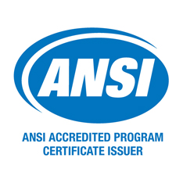

**ANSI Accredited Since 2010**